**Examen - Optical fibre networks**

**Paul JOLIVET – Jan 2024**

Calculator use is permitted

Access to course document is allowed

**Part 1 - Quiz:**

(12 points)

*Take care, several answers may apply for each question. A point is given to any answer with all correct answers selected. No negative point applies here.*

Q1: The wavelength used for communication in optical fibre is

* The whole visible spectrum
* Below (in terms of wavelength) the visible spectrum
* Above (in terms of wavelength) the visible spectrum

Q2: The typical wavelengths used for single mode optical fibre are

* 800nm and 1600nm
* 850nm and 1300nm
* 1310nm and 1550nm

Q3: Laser consists of a coherent light, coherence is about

* Wavelength/light
* speed/celerity in vacuum conditions
* temporal

Q4: Refraction (in physics) is about variation

* speed/celerity in vacuum conditions
* wave frequency
* propagation direction

Q5: Refraction (in physics) is related to

* the medium and characterized by an index
* the duration of propagation in a medium and measured by a time
* a variable ratio, combination of the wavelength and propagation speed

Q6: Reflection (in physics) is related to

* the use of mirrors to filter the wavelength
* the variation of propagation direction due to the change of medium
* the use of prism to enable bi-directional communication

Q7: Reflection applied to optical fibre area

* allows to contain the wavelength in the optical fibre thanks to a coating
* may provoke signal attenuation by refraction
* only applies to multimode optical fibre

Q8: Refraction index typical values are

* air: $n_{air}≈1$
* vacuum: $n_{0}=1$
* water: $n_{}=0,23$

Q9: Attenuation in Optical Fibre is about

* A variation of frequency
* Loss of the signal getting out of the waveguide
* The signal loosing energy

Q10: Chromatic dispersion is signal spreading due to

* Non coherent medium
* Variation of speed among the bandwidth
* Multiple reflections during the propagation

Q11: The material the most used for telecommunication fibre is

* Fluor zirconate
* Chalcogenide glass
* Silicium

Q12: The typical thickness of the core for telecommunication fibre is

* 10 nm
* 10 µm
* 100-150 µm

Q13: The multimode optical fibre characteristics compared to single mode

* Has a thicker core
* Has a multicore architecture
* Allows to reach longer distances with less attenuation

Q14: The bending constraint of optical fibre is

* A constant value related to the diameter of the core
* An opportunity for coupling fibres by splitting signal in a curve
* Related to reducing to acceptable the refraction consequences on the signal

Q15: Optical fibre of different types (G655, G652…) can be soldered together

* As long as the overall thickness of the cable is identical
* Only in limited cases of compatibility of the core
* They can actually never be combined

Q16: The typical use of optical fibre is

* G654 for intercontinental cables
* G655 for long haul connections, was developped as an optimisation for WDM communication
* G652/657 for terrestrial networks

Q17: In Optical Fibre area, SFP

* Embed the laser diod
* Code the signal from binary to analogue
* Means Small Form Factor Pluggable

Q18: Coupler for Optical Fibre consist in

* Combining the traffic of two fibres into one
* Splitting the trafic of one fibre into two (or more)
* Filtering signals on one optical fibre

Q19: Among the following components, which can only be active

* Splitter
* Amplifier
* Attenuator

Q20: Couplers are typically used in the FTTH networks for

* Synchronizing traffic
* Broadcasting data (for instance video) over groups of users
* Collecting traffic of up to 128 users on a single fibre

Q21: Multiplexing on optical fibre

* Allows to share the fibre resource between multiple waves
* Is usually based on CDMA solutions
* Reduces the capacity for each wavelength

Q22: WDM is about

* Providing a solution for bi-directionnal use of the optical fibre
* Multiplexing signals on single fibre
* Using Time Division multiplexing

Q23: CWDM

* Means Coarse Wavelength Division Multiplexing
* Is limited to 1Gbps traffic
* Is safer than DWDM in terms of interferences between wavelength

Q24: PON architecture

* Is based on loops
* Is largely used on FTTH networks
* Supports point to point connection, for instance for FTTO service

**Part 2: Exercises and calculations**

**Section 1: Optical fibre technology**

In this exercise, you may need the following formulas and values

|  |  |
| --- | --- |
| Formulas: $$v=\frac{c_{i}}{λ_{i}}$$ $$n_{i}=\frac{c_{0}}{c_{i}}$$ | $λ_{i}$ Wave length (m)  𝑣 Frequency (Hz) $c_{i}$ celerity (m/s) $c_{0}$ = 300 000 *k*𝑚/𝑠 $c_{water}$ = 225 000 *k*𝑚/𝑠  *i* is the index of the medium $n_{i}$ refraction value with : $$n_{0}=1$$ $$n_{glass}=1,49$$ $$n_{silica}=1,457$$ |

1. Medium characteristics
2. Would you expect that celerity of light in the water would be higher or lower than in vacuum? why?

Lower

…due to density of the medium : vaccum is null while water is much higher

1. What is the frequency of a telecom laser with a wavelength of $1,5\text{µ}$ m in vacuum conditions?

$$v=\frac{c_{i}}{λ_{i}}$$

applied to the question, formula becomes $v=\frac{c_{0}}{λ_{}}=\frac{300 000×{10}^{3}}{1.5×{10}^{-6}}=\frac{3}{1.5}×{10}^{14}=2 × {10}^{14} Hz$ = 200 THz

1. What is the propagation speed of light in glass?

$$n_{i}=\frac{c_{0}}{c_{i}}$$

applied to the question, formula becomes $$c_{glass}=\frac{c_{0}}{n_{glass}}=\frac{300 000}{1.49}=201 342 km/s= 2.01342×{10}^{8} m/s$$

1. What is the propagation speed of light in a silica medium?
$$c_{silica}=\frac{c_{0}}{n_{silica}}=\frac{300 000}{1.457}=205 902 km/s= 2.05902×{10}^{8} m/s$$

2. Propagation in optical fibre and effects on transmission
3. What would be propagation time of the wave between Paris and Noumea (21 000 km)? (consider optical fibre in silica)

Taking into account $$c_{silica}=205 902 km/s$$

The theoretical propagation time would be :

$$t=\frac{21000}{205902} = 0.1 s=100 ms$$

1. The actual measured propagation time is 294 ms,
   1. How would you explain the difference

The actual propagation time is almost 200 ms higher than the theoretical propagation time.

This can be explained by equipments in charge of routing or regenerating the signal on the way. These equipments introduce latency

* 1. Do you expect that equipment on the way would impact latency? What type of equipment and why?

Routers

Regenerators for the signal

1. How would you define latency for the services on such a link?

Latency for the services is the roundtrip spent time, i.e. the delay between a request and the related reply. Here, this would be 294 x 2 = 588 ms, a bit more than half of a second

1. How much attenuation of the signal will slow down the propagation time in such a trip?

Attenuation of the signal is a loss of energy. This does not affect the propagation time, only the quality of the signal

**Section 2: Optical fibre networks**

The following exercise is based on the network topology summarized in the following figure

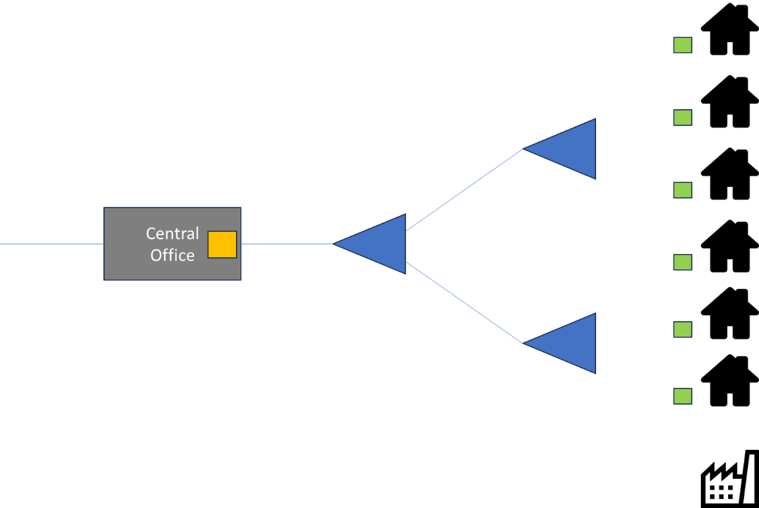

1. Network topology
2. How would you name the topology shown in the figure above?

The topology represented above is a tree topology

1. What does this topology brings compared to loop topology?

This topology brings the capability to couple signal and thus optimise the resource. This is also an accurate topology to deploy a high level of capillarity (while with a loop, there will always be places not that close to the infrastructure.

1. Name the typical FTTx network based on that technology?

FTTH

1. Network elements
2. Can you explain what are the following elements and their role
   1. The orange square in the Central Office

OLT (Optical Line Termination) is the collecting point for the traffic. It is connected with the ONT (see below) and establish a secured link with it.

* 1. The green square in houses

ONT (Optical Network Termination) is the user termination point that allow the access to FTTH network. See above, it is connected with the OLT.

* 1. The blue triangles

The blue triangles are Couplers. This equipment allows to share the optical fibre resources with up to 128 users.

1. Is this topology based on dedicated or coupled fibre?  
   Explain the principle and rational for this network structure?

This is based on coupled fibre, however, this does not prevent from having dedicated fibre.

High capillarity, optimisation of the resource.

1. Can a topology oriented on coupled fibre offer end to end dedicated fibre to some customer? If ever, what would be the use case for that?

It can. This is typically used for FTTO/H.

1. GPON technology
2. What is the typical rate for GPON technology?

As the name mentions, the typical rate is 1G, it can go up to 2.4G. The latest implementation allows a symmetric rate on GPON.

1. Is that rate symmetric?

Can be

1. What are evolutions in terms of rate?

XGSPON (10G), 25GPON, 50GPON… and one day : 100GPON